**NUnit to Test an OOP Based System for Storing School Data**

**Practice Project**

**Aim:**

Use NUnit to do unit testing for an existing OOP backend prototype application for storing school data.

**Github link:**

[**https://github.com/Sukirthalakshmanan1/UnitTest**](https://github.com/Sukirthalakshmanan1/UnitTest)

**Procedure:**

* Create a class library Unit Test and add classes student,teacher and subject
* Add necessary properties.
* Create another library student.Test
* Install Nuget package Nunit in the project and NunitTestAdapter in student.Test
* Add validation methods in class in student.Test
* TestFixture is the attribute that marks a class that contains tests and, optionally, setup or teardown methods
* Write the validations for testing the classes student,teacher and subjects.
* Build the solution
* Open Test -> Test explorer and run all the testcases.
* We can observe the Test cases passed , failed and not run.

**Output:**

**Test Explorer:**

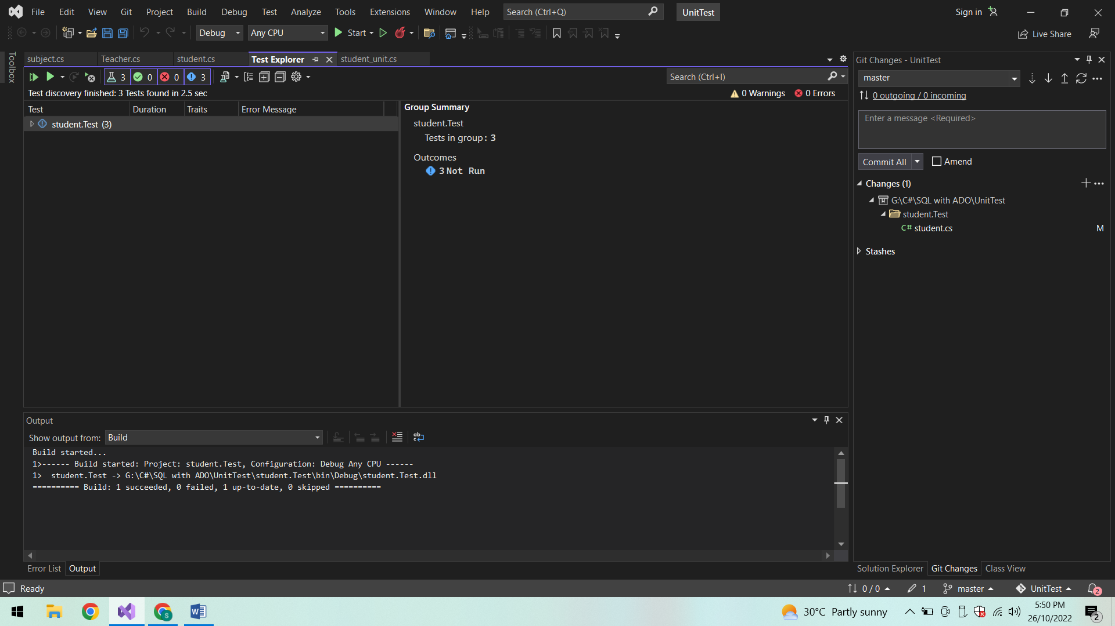

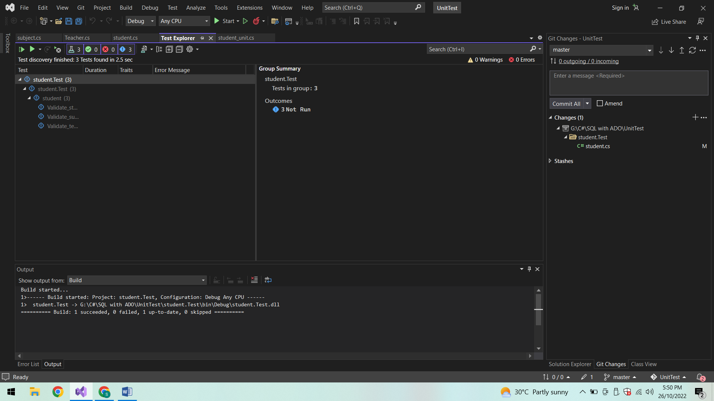

**Validate student:**

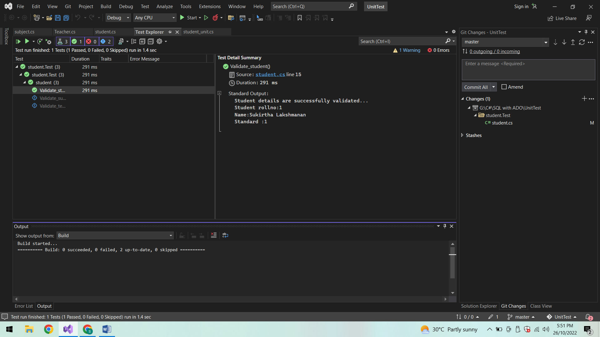

**Validate subject:**

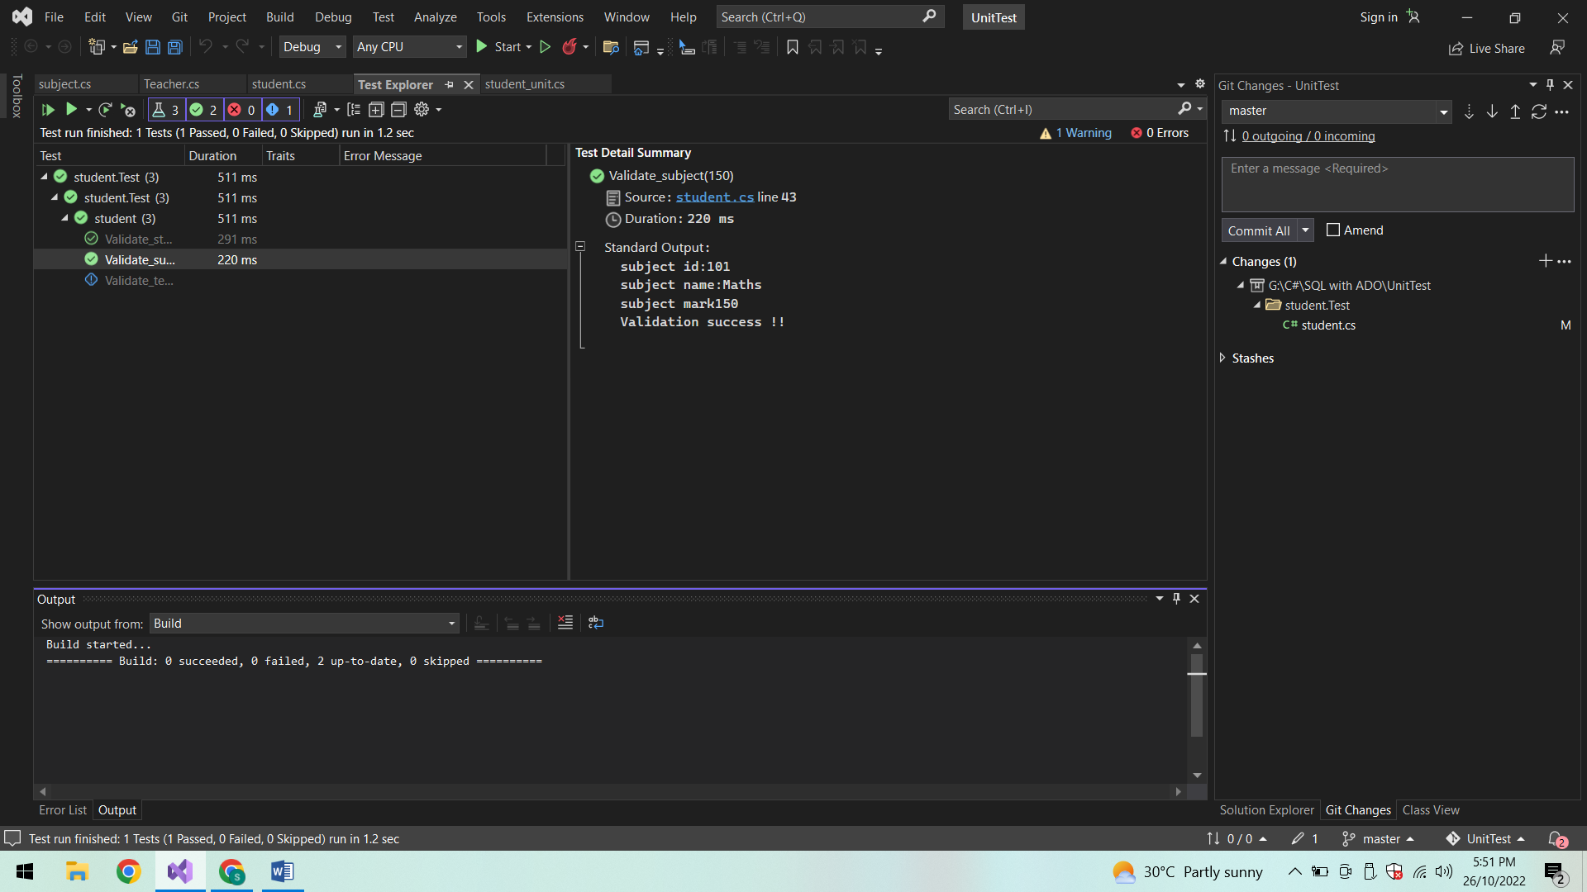

**Validate Teacher:**

**Testcase 1:**

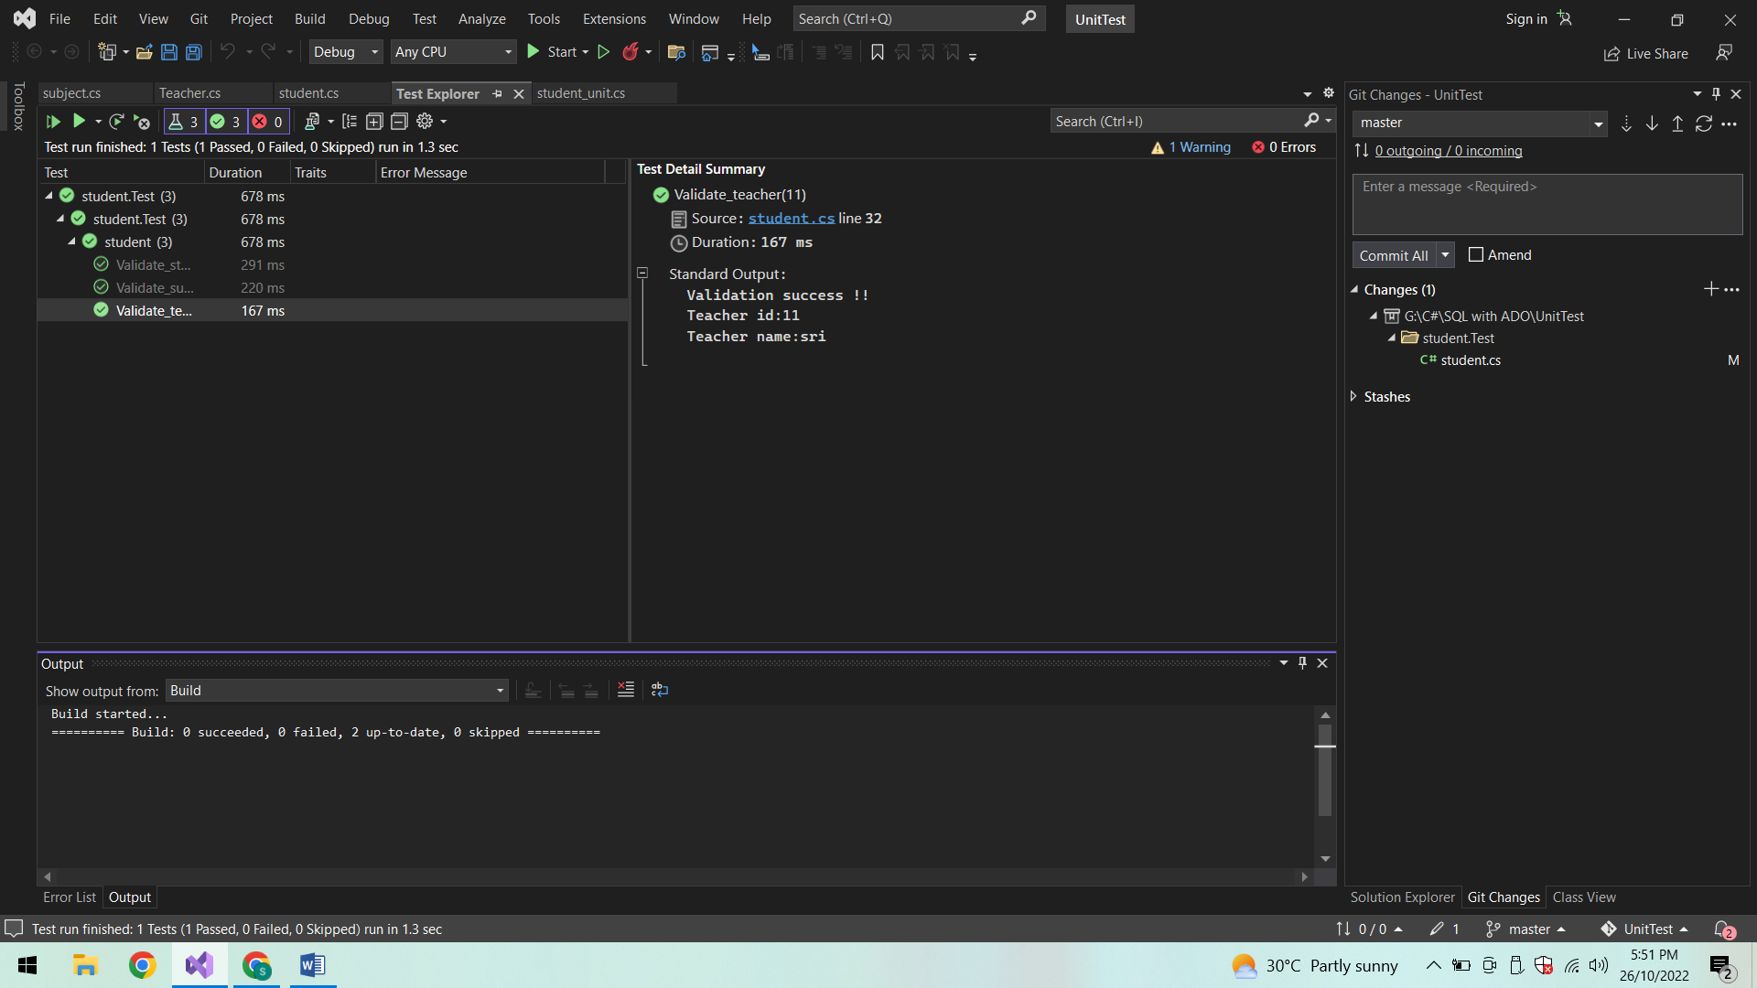

**Testcase 2:**

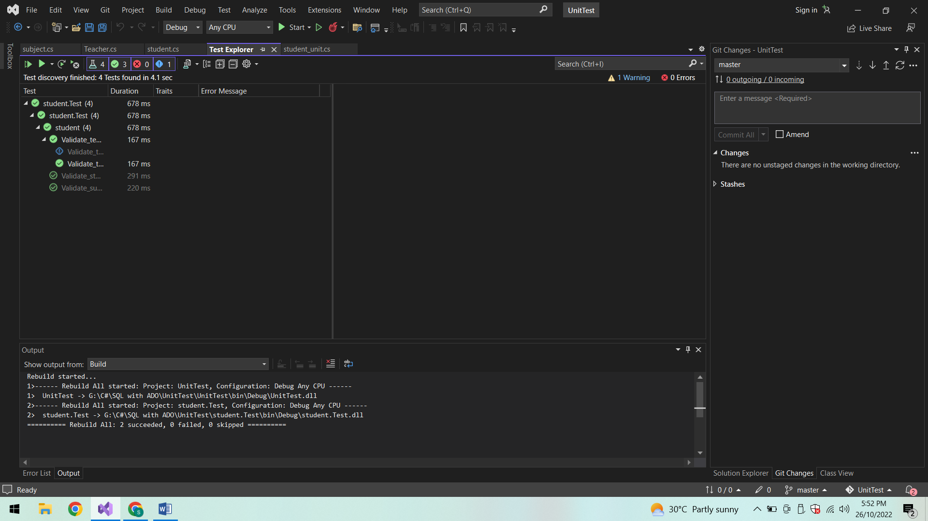

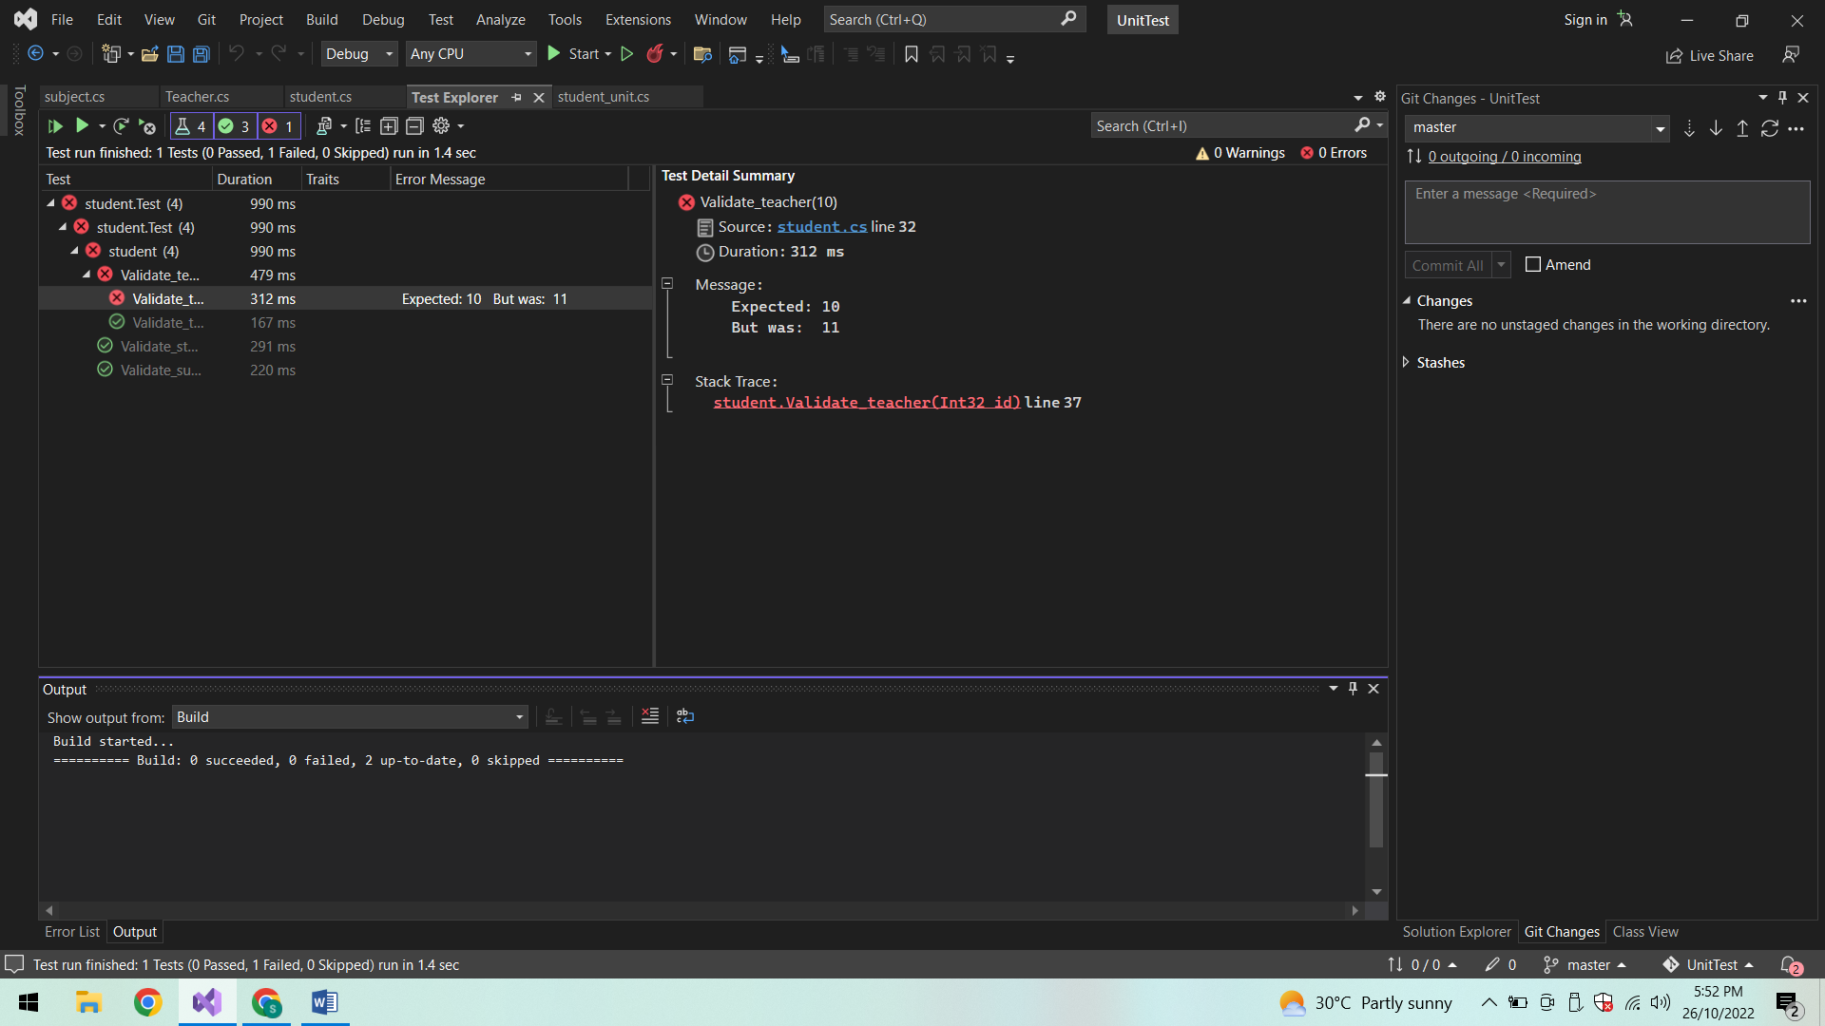

**Group summary:**

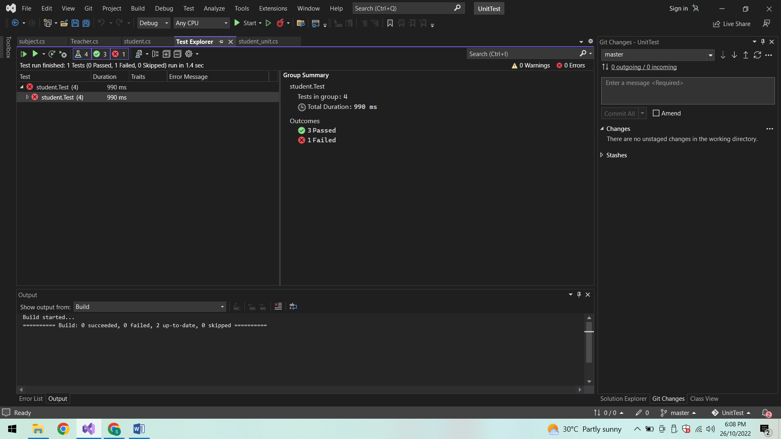

**Student_unit.cs:**

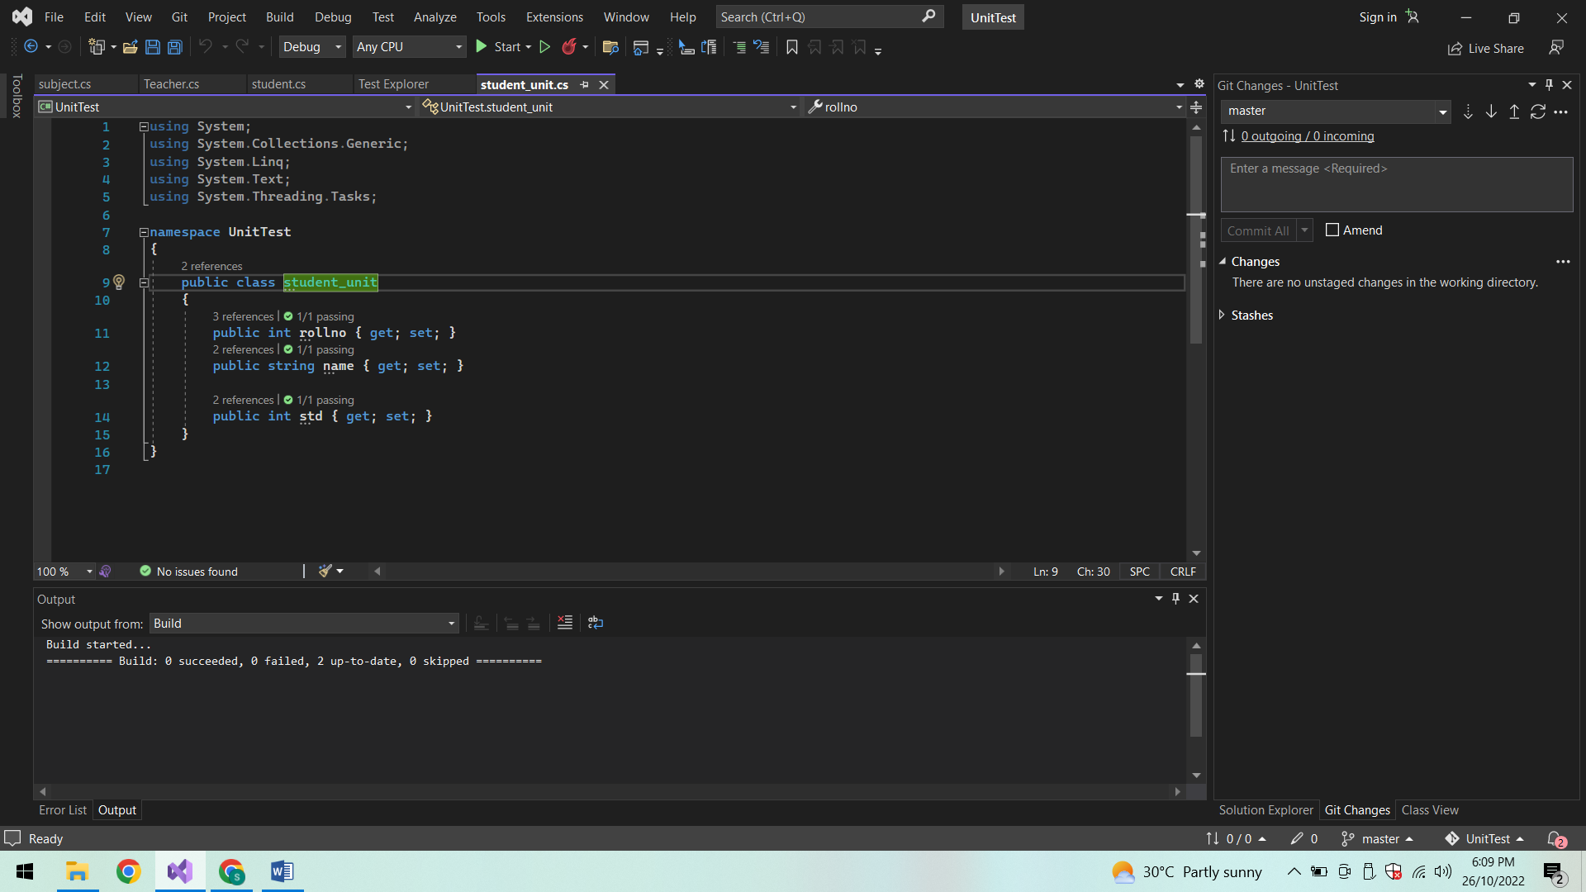

**Teacher.cs:**

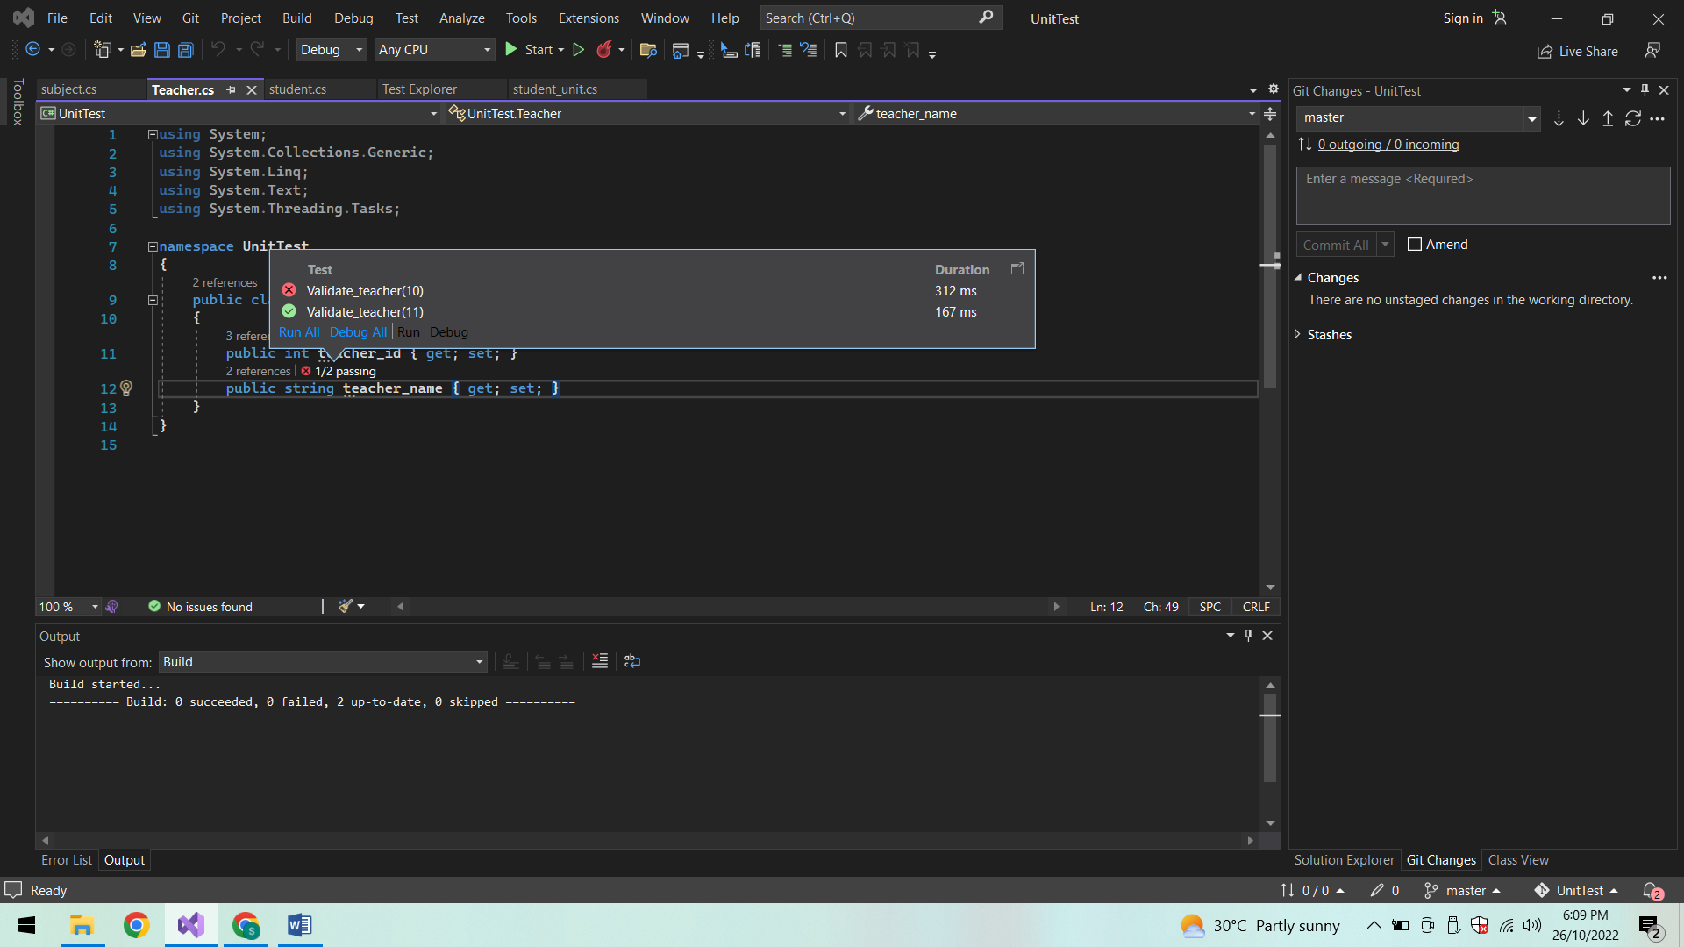

**Subject.cs:**

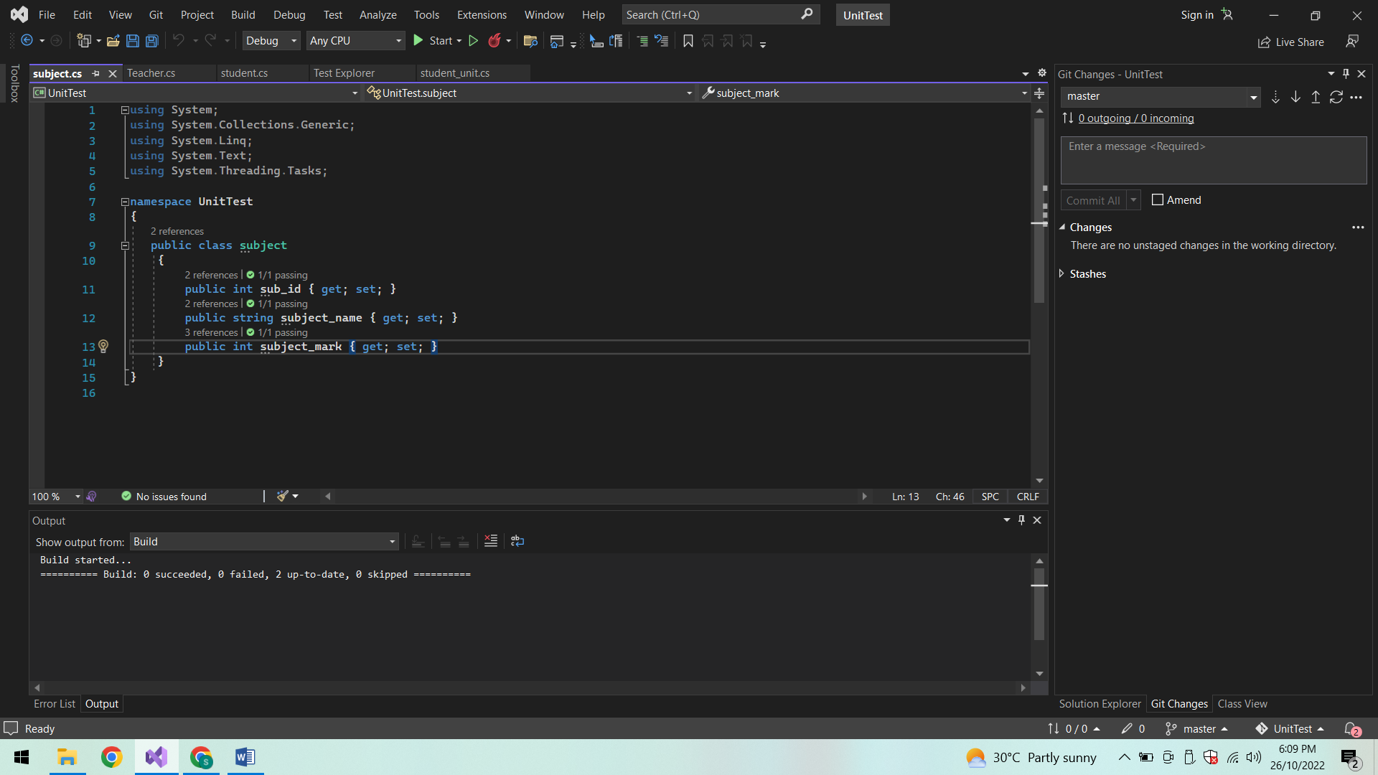

**Conclusion:**

Thus the Unit testing is done for an OOP based system successfully.